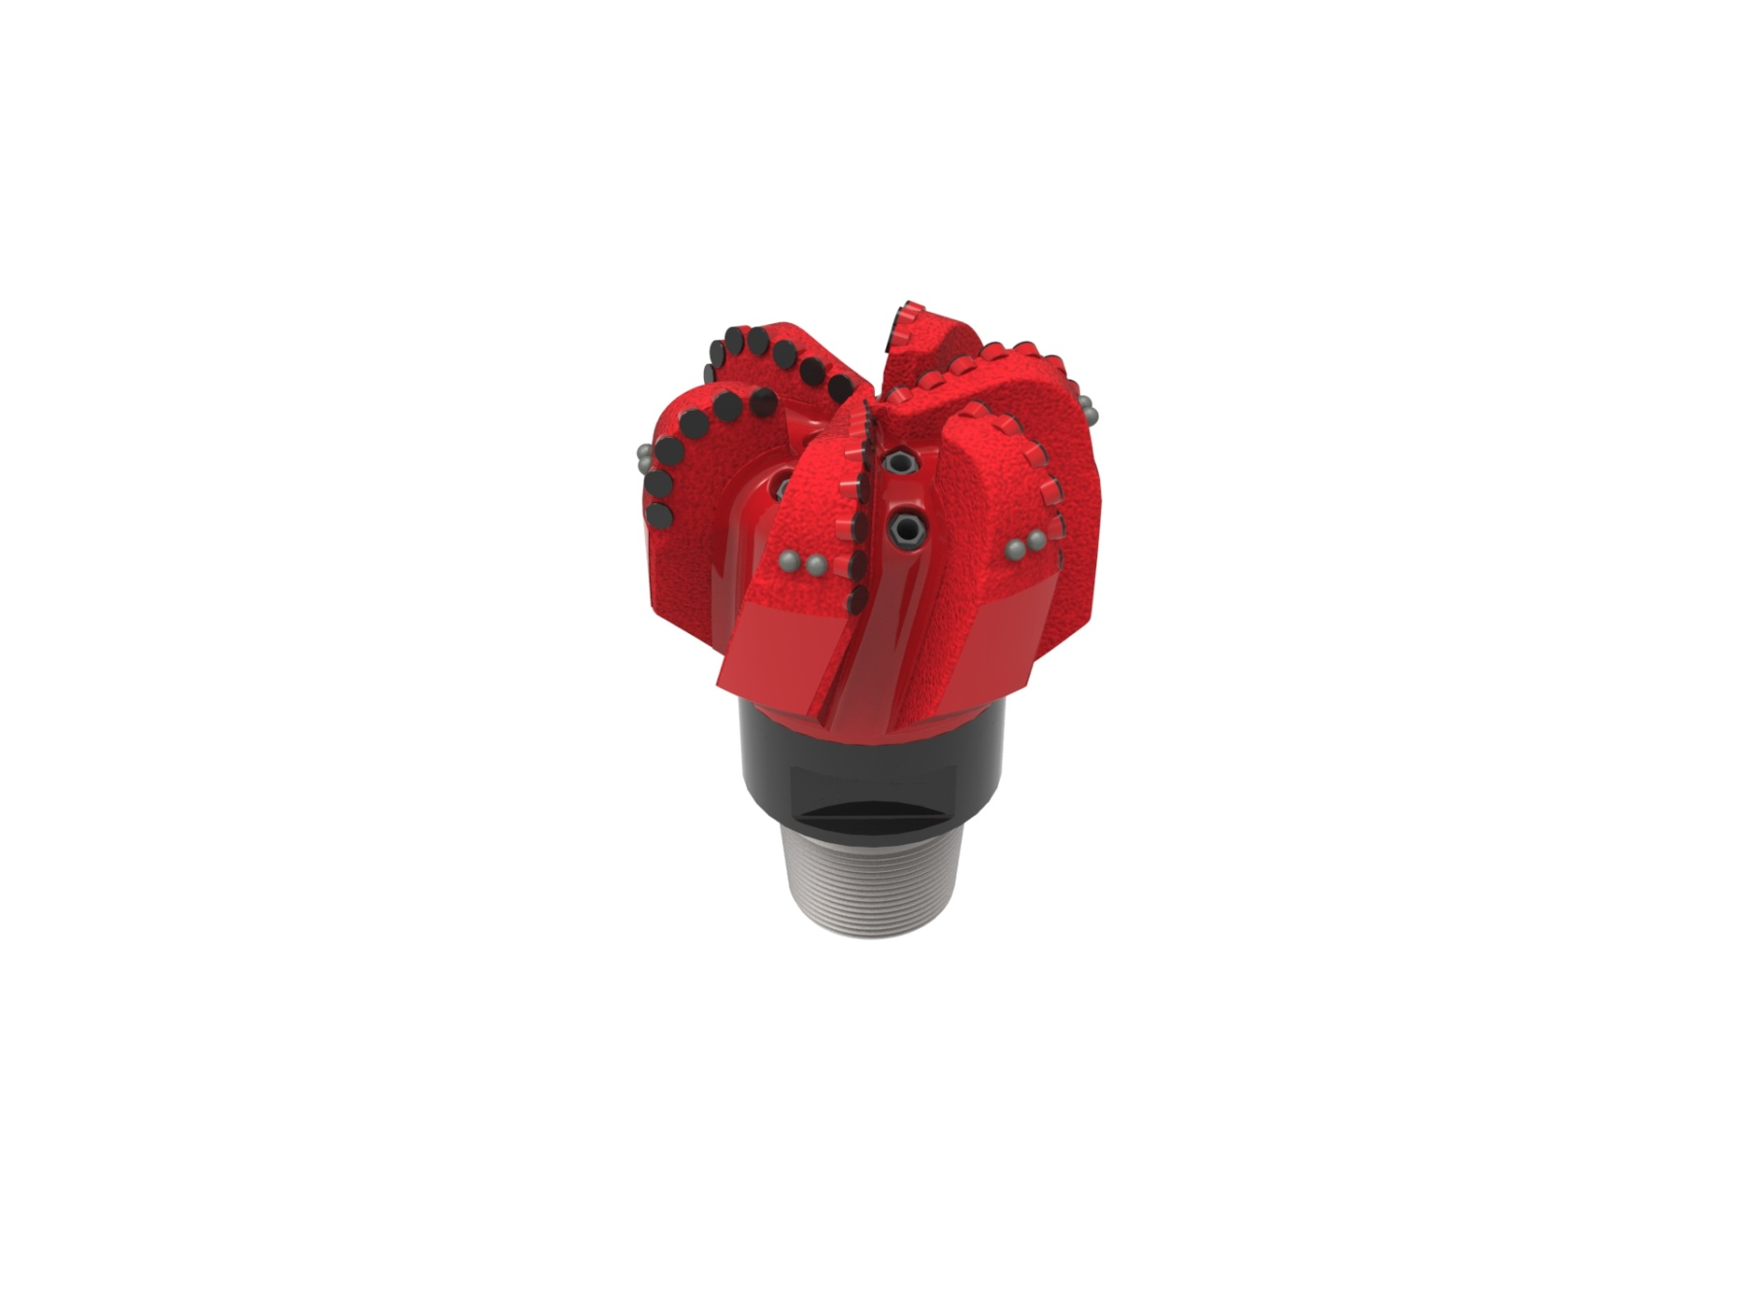
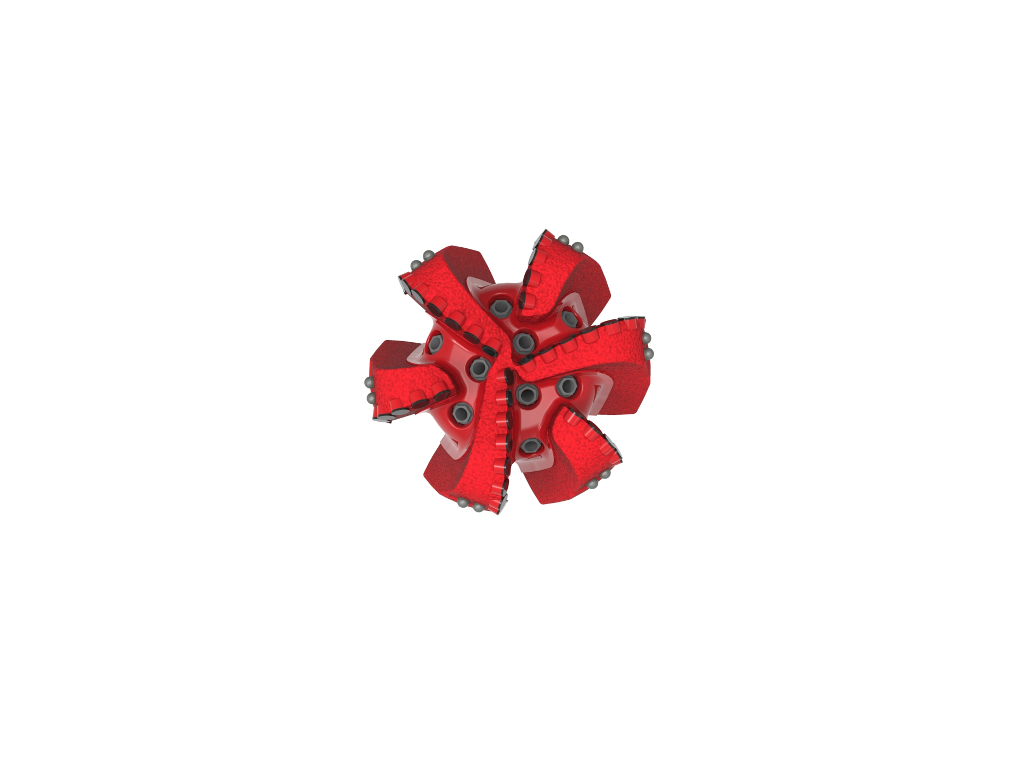

Drill Bit Specifications:
Cutter Size | 3/4”
Cutter Count (Total, Gage) | 43,7
Blade Count | 6
Gage Length (Inches) | 3.00
Nozzle Count (Primary, Sec.) | 9
Nozzle Series (Primary, Sec.) | 60
JSA (Sq. Inches) | 33.51
Max. TFA (Sq. Inches) | 3.34
Operating Parameters:
Max. Hydraulic Flow Rate (GPM) | 1041
Max. Weight on Bit (1,000 Lbs.) | 60
Make-up Torque (ft/lbs) | 40,563
Nominal Dimensions:
Overall Length (Inches) | *17.89
Make Up Length (Inches) | *13.01
Bit Breaker | SKB-21011
Connection | Ø6-5/8" API Reg.
Approx. Weight (Lbs.)  *Long tool joint available upon request (adds 6” to fishing neck, makeup and overall length, and 64 lbs to approximate weight). | *210

Standard Features:

- Premium grade cutters maximize ROP and Life
- Large open face volume assists cuttings removal
- Nine nozzles optimize blade cleaning and cuttings removal

619-SR9(K) Nomenclature Explained:

• | 6 | = | Number of Blades
• | 19 | = | Primary Cutter Size (19mm)
• | SR+ | = | Single Row of Cutters
• | 9 | = | Number of Nozzles
• | K | = | Bullets


